Strapi on AWS ECS with Aurora DB: Setup Documentation with GitHub Actions CI/CD

Overview
This document outlines the deployment of Strapi CMS on AWS ECS with Fargate and Amazon Aurora MySQL for production and staging environments, integrated with a GitHub Actions CI/CD pipeline. The setup uses Terraform with a modular structure for Infrastructure as Code (IaC), Docker for containerization, Route53 for DNS, and CloudWatch for logging and monitoring. All AWS resources, including ECR and IAM roles, are managed via Terraform.

Assumptions
- AWS account with sufficient permissions.
- Domain name (srivamsi.com) registered and managed in Route53.
- GitHub repository with Terraform modules, Dockerfile, and GitHub Actions workflow.
- Basic familiarity with AWS, Docker, Strapi, Terraform modules, and GitHub Actions.

Prerequisites
- Install Terraform locally (optional, for manual testing): https://www.terraform.io/downloads.html
- Configure AWS CLI locally (optional): aws configure
- Set up a GitHub repository with the Terraform modules, Dockerfile, and GitHub Actions workflow.

Setup Process

1. Infrastructure Setup
The Terraform configuration is organized into modules:
- Root Module (main.tf): Orchestrates VPC, Aurora, ECS, Route53, ECR, and IAM modules.
- VPC Module (modules/vpc): Creates a VPC with public and private subnets across two availability zones, internet gateway, and route tables.
- Aurora Module (modules/aurora): Deploys Aurora DB clusters for prod and staging, with security groups and Secrets Manager for credentials.
- ECS Module (modules/ecs): Sets up an ECS cluster, task definitions, services, ALB, and CloudWatch logging for prod and staging.
- Route53 Module (modules/route53): Configures DNS records for prod and staging.
- ECR Module (modules/ecr): Creates an ECR repository for the Strapi Docker image.
- IAM Module (modules/iam): Creates an IAM role with OIDC for GitHub Actions to access AWS resources.

2. Aurora DB Deployment
- Aurora Cluster: One cluster per environment (prod, staging) with MySQL 8.0.
- Multi-AZ: Instances in us-east-1a and us-east-1b for high availability.
- Credentials: Stored in AWS Secrets Manager, referenced in ECS task definitions.
- 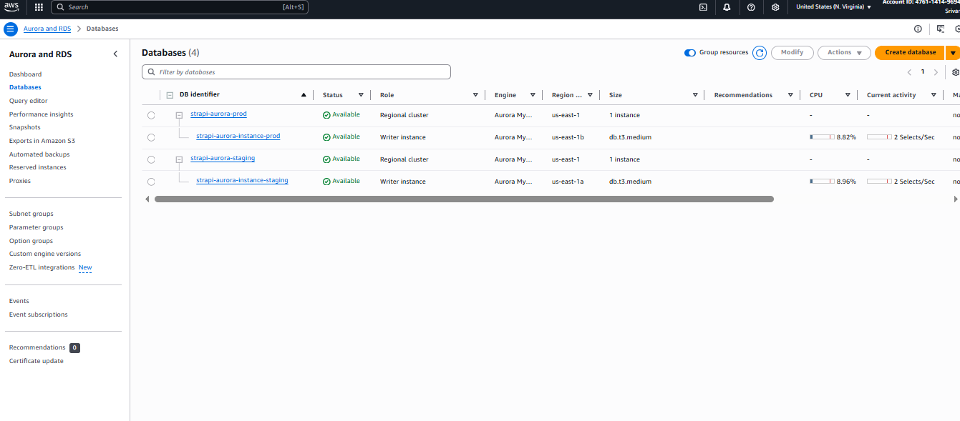

3. Strapi Configuration
- Dockerfile: Uses the official strapi/strapi:latest image and copies custom database configuration.
- Database Config: config/database.js connects Strapi to Aurora using environment variables.

4. ECS Deployment
- Cluster: Single ECS cluster for both environments.
- Task Definitions: Separate definitions for prod and staging, referencing the Docker image and Aurora credentials.
- Services: Fargate-based services with ALB integration for HTTP traffic.
- ALB: Application Load Balancers for prod and staging, routing traffic to ECS services.
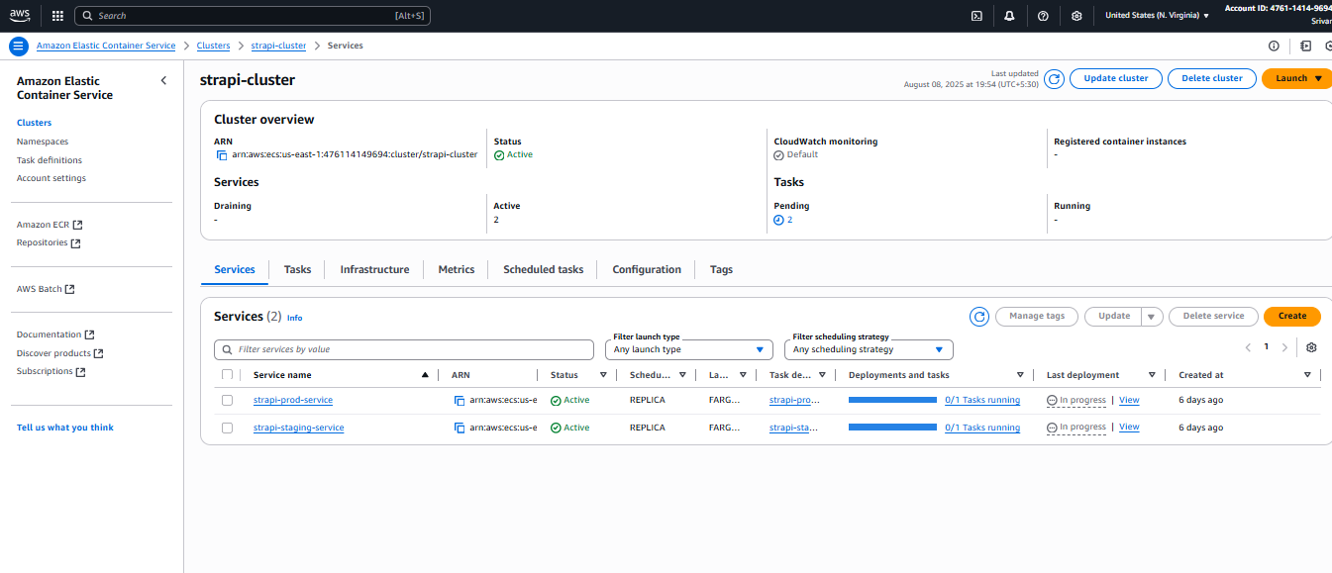

5. DNS Configuration
- Route53: Configures strapi.srivamsi.com (prod) and staging-strapi.srivamsi.com (staging) as CNAME records pointing to ALB DNS names.
- Update the domain_name variable in main.tf with your actual domain.
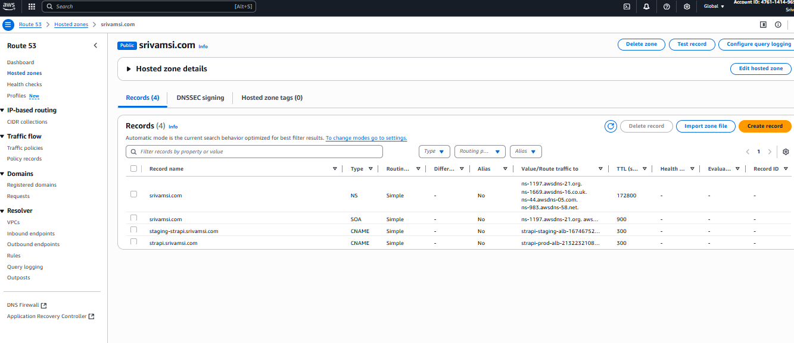

6. Logging and Monitoring
- CloudWatch Logs: Strapi containers send logs to /ecs/strapi-prod and /ecs/strapi-staging.
- CloudWatch Alarms: Monitor CPU utilization for ECS services and Aurora clusters, triggering on >80% usage.
- Access logs via AWS Console or CLI:
- aws logs tail /ecs/strapi-prod

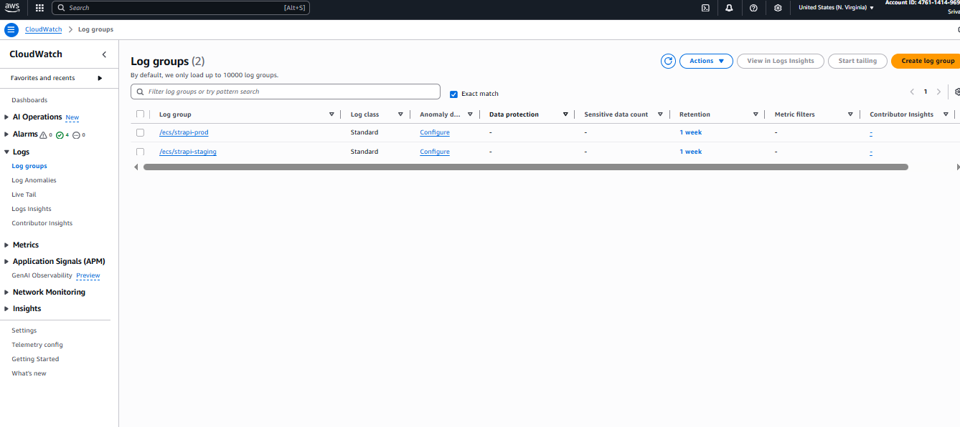

7. Security
- VPC: Isolates resources with private subnets for Aurora.
- Security Groups: Restrict Aurora access to ECS tasks only.
- Secrets Manager: Stores database passwords securely.
- Strapi Admin: Secure via Strapi's built-in authentication (configure post-deployment).
- IAM Role: Uses OIDC for GitHub Actions, eliminating long-lived credentials.
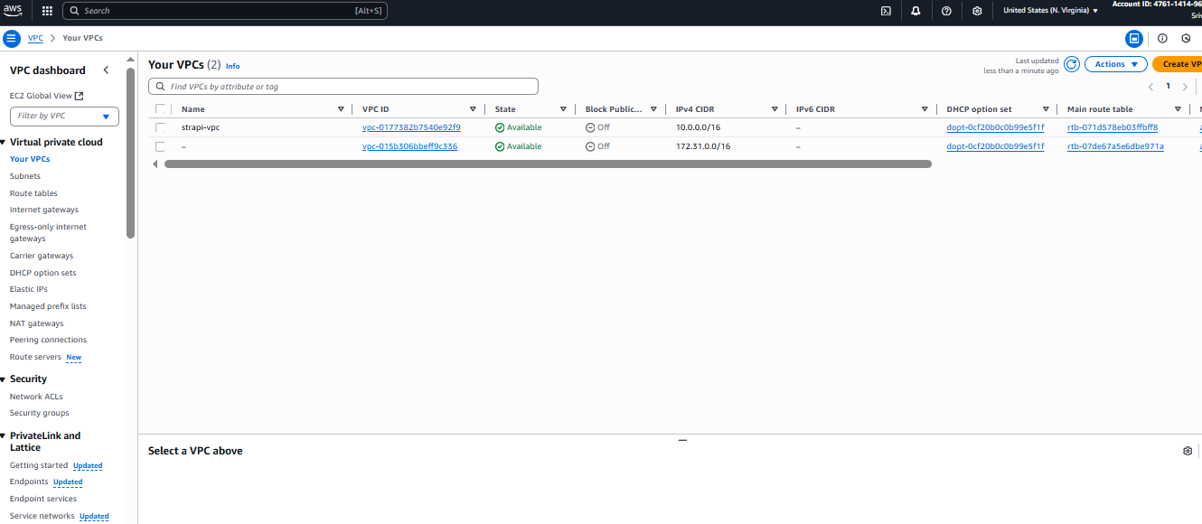

8. GitHub Actions CI/CD Setup
- Workflow File: .github/workflows/deploy.yml defines a pipeline to:
  - Checkout code from the GitHub repository.
  - Build the Strapi Docker image.
  - Push the image to the AWS ECR repository created by Terraform.
  - Initialize, plan, and apply Terraform configurations.
- Setup Steps:
  - Create a GitHub repository with the following structure:
  - .
  - ├── main.tf
  - ├── modules/
  - │ ├── vpc/
  - │ │ ├── main.tf
  - │ ├── aurora/
  - │ │ ├── main.tf
  - │ │ ├── variables.tf
  - │ ├── ecs/
  - │ │ ├── main.tf
  - │ │ ├── variables.tf
  - │ ├── route53/
  - │ │ ├── main.tf
  - │ │ ├── variables.tf
  - │ ├── ecr/
  - │ │ ├── main.tf
  - │ ├── iam/
  - │ │ ├── main.tf
  - │ │ ├── variables.tf
  - ├── config/
  - │ ├── database.js
  - ├── Dockerfile
  - ├── .github/
  - │ ├── workflows/
  - │ │ ├── deploy.yml

  - Update the github_repo variable in main.tf with your GitHub repository (e.g., your-github-username/strapi-deployment).
  - Update the domain_name variable in main.tf with your actual domain.
  - Add the IAM role ARN to GitHub repository secrets:
    - After running terraform apply locally to create the IAM role, note the github_actions_role_arn output.
    - Go to repository Settings > Secrets and variables > Actions > New repository secret.
    - Add GITHUB_ACTIONS_ROLE_ARN with the ARN value.
  - Push changes to the main branch to trigger the workflow.
- Pipeline Execution:
  - The workflow builds the Docker image, pushes it to ECR, and applies the Terraform configuration to deploy or update the infrastructure.
  - On code changes (e.g., Strapi config updates), push to the main branch to trigger the pipeline.
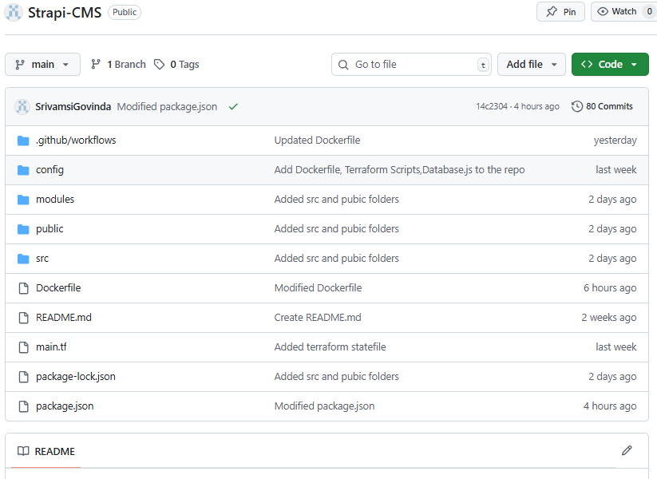

https://github.com/SrivamsiGovinda/Strapi-CMS/tree/main/.github/workflows

Validation
- Access Strapi instances:
  - Production: http://strapi.srivamsi.com/admin
  - Staging: http://staging-strapi.srivamsi.com/admin
- Verify database connectivity:
  - Log in to Strapi admin and create a test content type.
  - Check CloudWatch logs for errors: /ecs/strapi-prod and /ecs/strapi-staging.
- Monitor CloudWatch alarms for CPU usage.
- Test Route53 DNS resolution using strapi.yourdomain.com.
- Check GitHub Actions workflow logs in the repository's Actions tab for successful deployment.

